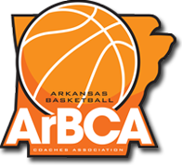

TOP 5 Banquet
The Arkansas Basketball Coaches Association will hold its 8th annual “Top 5” basketball banquet on Monday April 18, 2022 at the Benton Event Center. The banquet recognizes the starting five from each classification 1A-6A for boys and girls basketball players in the state. Also, the coach of the year for each classification will be honored. All honorees were voted on by the ArBCA membership at the conclusion of the 2021-2022 season.
KATV sports director Steve Sullivan will be the master of ceremonies and Matt Zimmerman (Coach Z) will be our keynote speaker. The program will begin at 6:30 pm with the meal catered by Corky’s.
Each player being recognized will receive three tickets and their coach will receive two tickets. Additional tickets are $10 for ArBCA members. Additonal tickets for family members are $20 and can be purchased at the door.
All ArBCA members in attendance will vote on the Overall Player and Coach of the Year.

For more information, call Charles Hervey at 501-428-3553 or James Bates at 501-680-0441.

